Princess Sumaya University for Technology

King Abdullah II Faculty of Engineering

Computer Engineering Department



**Embedded Systems.**

**Project on PIC16F877A. Smart Home System.**

**Group 7.**

|  |  |  |  |
| --- | --- | --- | --- |
| *Authors:* |  |  | *Supervisor:* |
| Laith Barakat | 20190730 | NIS. | Dr. Belal Sababha |
| Majd Shrouf | 20190695 | NIS. |  |
| Mohammad Baker | 20190454 | Computer Eng. |  |

***January 23,2023***

***Abstract***

*The main idea of this project is to get experience about embedded system and how to design it using PIC16F887A to do anything. We need to know there are to main part of designing embedded system: hardware design and software design (Source code)/(Firmware). but on this project, we will design an embedded system for Smart home system . for example, if there one has a house we will use our embedded system to control the temperature and the lights depends on the state for example if the person on his home, and it is day and the temperature is to high the, fan will work of high speed and the lights will be off else window will, fan will be off and Lights will be on.*

# Table of Contents

1. Introduction 2
   1. Objectives 2
   2. Theory 2
   3. Equations Guidelines 2
2. Procedure and Methods 3
3. Results and Discussion………………………………………………………………………………………………………..3
   1. Figures 3
   2. Problems and recommendations 9
4. Conclusions 10
5. References 10

#### INTRODUCTION

In this project we will design a smart home system using a microcontroller (PIC16F877A), the design will include the PIC microcontroller, Clock Oscillator 8-MHZ, Push button, IR sensor, servo motor, light sensor, LEDS, temperature sensor, DC motor (fan), LCD display, flame sensor, ADC, and drivers to make the components and circuit safe and work in the right ways. The drivers that will be used in the system are H-bridge, resistance and transistors (NMOS or PMOS). Before we start we need to know that we will use the Push button to open and close the system, we will use ADC for the sensors that give to us analog reading and we need clock source on the system and it will be the crystal oscillator (8 MHZ).

Technology has become an essential aspect of life, and it is indispensable. One of the aspects encompassed by technology is the field of embedded systems and their applications in daily life. One such application of embedded systems in life is the creation of smart homes, which offer numerous advantages in terms of security, convenience, modernity, and the provision of a comfortable environment.

* 1. OBJECTIVES
     + Design an Embedded system using pic microcontroller
     + Design a smart house using PIC16F788A.
  2. THEORY

We have 5 important theory on embedded system and they are:

* + - Embedded system is a computer designed to perform dedicate function.
    - Embedded system performs one or a few predefined tasks depend on very specific requirement.
    - Software written for embedded system usually called firmware.
    - Embedded system is systems do the same thing for the whole life.
    - When we design an embedded system, we need to design an infinite loop.
  1. EQUATIONS GUIDELINES:

Equation 1: Analog to Digital converter:

𝑉𝑘 = 𝐾 × 𝑉𝐻−𝑉𝐿 + 𝑉𝐿 = 𝐾 × 𝑉

+ 𝑉𝐿

Where:

2𝑛−1

𝑠𝑡𝑒𝑝

* Vk: The voltage of moving K steps or K levels.
* K: The number of steps or number of levels.
* VH: The max voltage on my range.
* VL: The minimum voltage on my range.
* n: The number of bits on (ADC).
* 2^n: The number of levels.
* VStep: The voltage for one step or one level.
* My range: form VL to VH.

The equation defines the input voltage that the temperature senor gives it to us depends on the case by using (ADC).

Note that (ADC) can read the voltages on range [VL, VH] and any voltages that are out of the range, (ADC) cannot read it. So, if their problem like that we need to offset the voltage to be on our range.

On our case VL=0 volt, VH= 5 volt and the number of bits for ADC= 10 bit so my range will be start from (0 volt) to (5 volt) and the number of levels will equal to 1024 level. So, the final equation will equal to [Vk= K*4.88 (v/step)] where the voltage 4.88 v is the voltage for each level.

#### PROCEDURE AND METHODS:

The methods we use to make the project:

* Design an Embedded system using PIC16F877A.
* Design a block diagram to know which components we will use for the project.
* Design a simple prototype for the final design.
* Make a software design for the project. // Attached with (File source code)
* Make a hardware design for the project.
* Make an Electrical design.
* Buy the components and Start working as a team.

# RESULT and Desiccation:

## Figures:

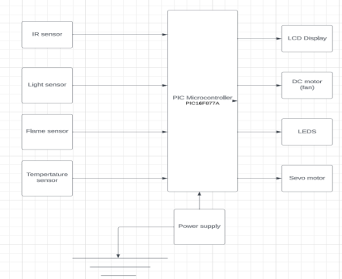

***Figure-1 Block diagram***

### Input and output devices:

Figure-1 show the input and output devices of the project as we see on this figure we have 4 input and 4 output of microcontroller the 4 input are LDR sensor , Temperature sensor, IR sensor and the Flame sensor . The 4 output are LCD display, Dc motor fan, LEDS and servo motor for the door.

We will use the power supply to give power for the whole system especially for the (PIC16F877A).

We will use Pushbutton-1 as Switch (on/off) to reset circuit.

We will use Pushbutton-2 to open and close the fan manually.

We will use Pushbutton-3 to open and close the door manually.

We will use Pushbutton-4 to open and close the LEDS manually.

We will use IR sensor to detect if someone is come to home or not if yes open the door using servo motor.

We will LDR sensor to know if it is night or day if it is night and someone at home the LEDS will be on else the LEDS will be off.

We will use Temperature Senor to know what is the temperature value on Celsius degree and the result will be play on LCD Display. Also, we will use (ADC) with temperature sensor to give voltages for the PIC16F877A to control the speed of motor fan and to control the window (on/off) depends on the temperature or Voltages or on the states generally.

We will Use Flame sensor to detect if there is a fire or not.

So, we conclude that PIC16F877A get input signals from the sensors and give output signals to output components.

### AutoCAD Prototype:

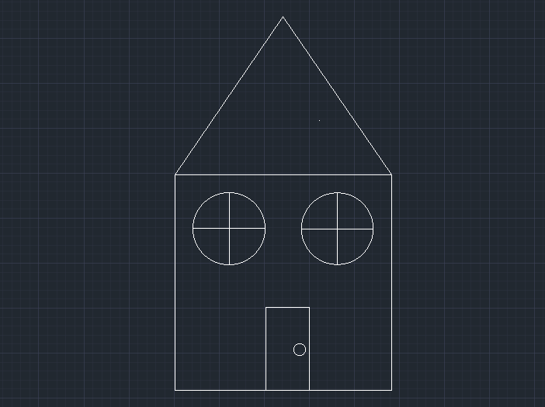

Figure-1

Figure 1 show the house on front view that we need to design it the embedded system on 2 dimensions and this is our prototype for the project.

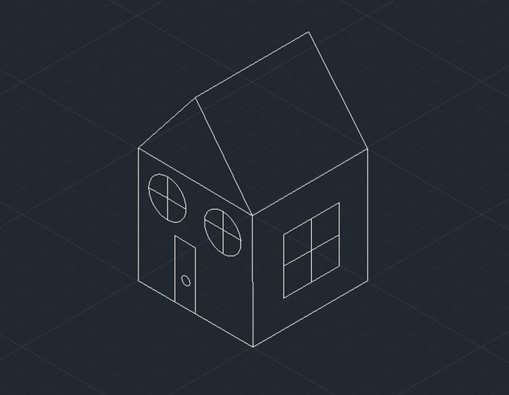

### Figure-2

Figure-2 shows the house on 3 dimensions by using isometric drawing.

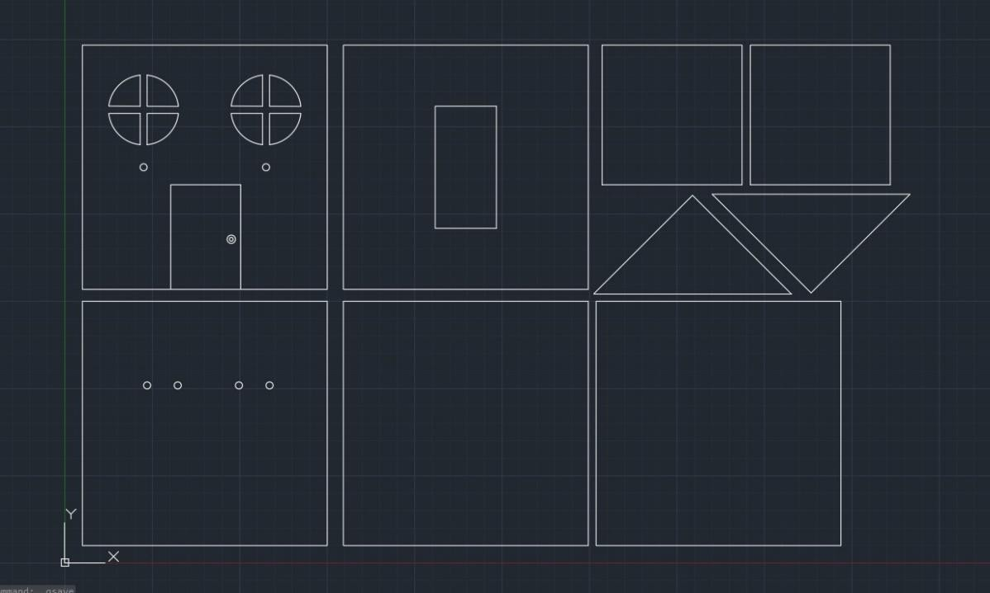

### Figure-3

Figure-3 show the design of the house on all views.

### Electrical Design:

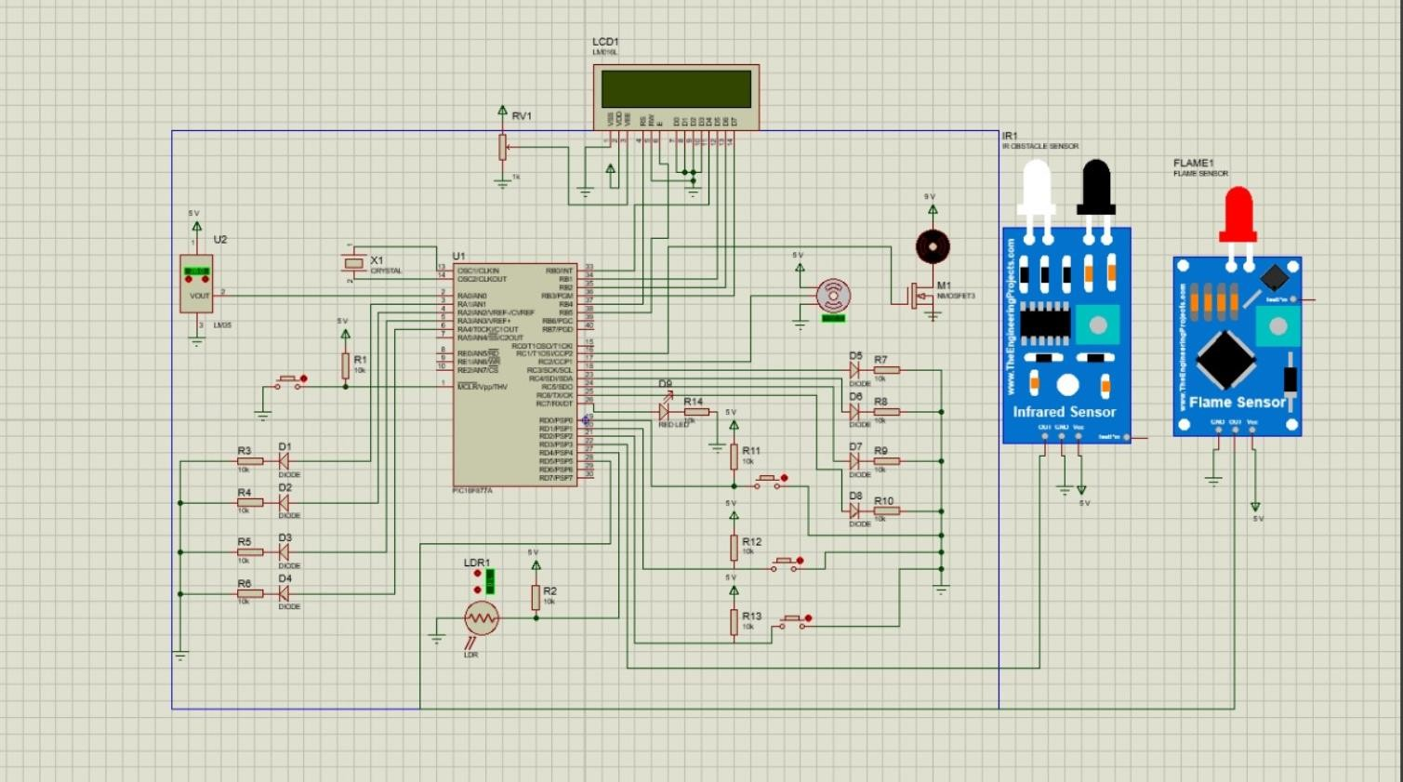

Figure-4

Figure-4 Shows the electrical design of the system.

### Final block diagram:

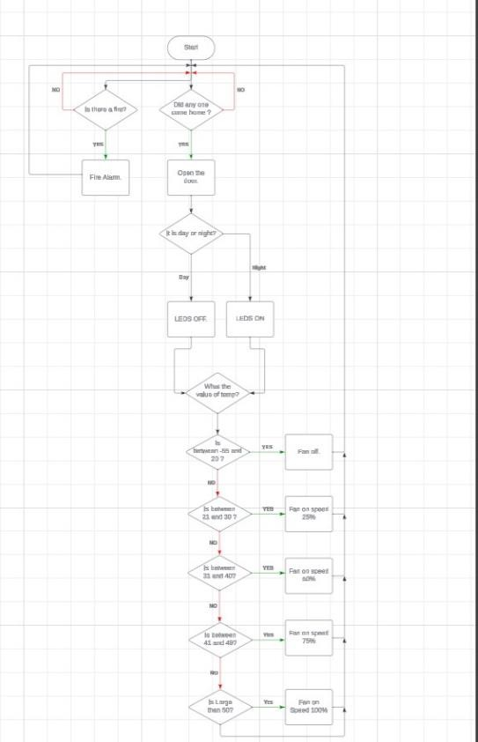

Figure-5

Figure-5 show the final block diagram for the project as we know on embedded system we need to design an infinite loop because embedded system work for the whole life and do the same thing with very specific requirements.

## 3.3 Problems and Recommendations:

When we start working at the project we have a lot of problems that we deal with it and they are:

* No experience on embedded system.
* Chose a suitable topic for the project depends on our skill.
* Time management, the project needs a lot of time to do it, hard to deal between the project and other subjects (homework’s, Quizzes, Exams) and hard to find a suitable time between us because each of us has different free time for the project.
* Find a place to buy the components which we need high quality, not expensive and near to the university.
* Problem on programing as we know embedded system has 11 chapters that we need to study them each chapter has main goal to learn a skill that we will be use on the project or on the future so we need to wait a lot of times before we start programming.
* Find a suitable way to work as a best team.
* Problem on applying because when we program the pic we do not what is the main problem of applying is from PC? Or from kit? Or from the code? Or from pic? So, it takes a long time to know where is the main problem and is waste of time.
* The components on the lab most of them not working so it is to hard to test the hardware design.
* The PCs on the lab are to slow when the working so they need to be improvement for the performance and most of PCs do not have the programs that we need to program kit.
* The lab is to small to deal with all students while they working at own project.

The recommendations:

* This course should be studying at least 6 hours the first 3 hours for beginner from chapter 1 to 6 and second 3 hours for the project and for advance start from chapter 7 to 11.
* Make an electronics shop on university to buy any electronic components not for embedded system but for everything with suitable cost.
* Improve lab of embedded specially the PCs for Performance.
* Make sure that every component on the lab are working to use them or for testing and any one who destroy anything they need to pay for it to be more responsible.
* Make at least 2 or 3 labs for embedded system for working on the project because there are large number of the student that they working on own project.

#### CONCLUSIONS

Finally, embedded system is a system whose principle function is not computational, but which controlled by a computer embedded within it. And we conclude that embedded system is often mass-produced and benefitting for economic scale, it is important for improving performance and it help us to developing the world.

# References

* [**https://en.wikipedia.org/wiki/Embedded_system**](https://en.wikipedia.org/wiki/Embedded_system)
* Designing Embedded Systems with PIC Microcontrollers Principles and Applications, 2nd edition, 2009, Tim Wilmshurst, ISBN: 978-1-85617-750-4
* **file:///C:/Users/moham/OneDrive/Desktop/PIC16F877A.pdf**
* [**https://www.youtube.com/watch?v=w3pvkKq8tZ0**](https://www.youtube.com/watch?v=w3pvkKq8tZ0)
* [**https://www.youtube.com/watch?v=OhwQmaCmDnM**](https://www.youtube.com/watch?v=OhwQmaCmDnM)
* [**https://www.alldatasheet.com/view.jsp?Searchword=LM324&gad_source=1&gclid**](https://www.alldatasheet.com/view.jsp?Searchword=LM324&gad_source=1&gclid=Cj0KCQiA-62tBhDSARIsAO7twbZf1RIZrlf8bqQeQY1n-ofTAeQrYlR47UnIihmuNeyFGgQHq2TekekaAs3AEALw_wcB)

[**=Cj0KCQiA-62tBhDSARIsAO7twbZf1RIZrlf8bqQeQY1n-**](https://www.alldatasheet.com/view.jsp?Searchword=LM324&gad_source=1&gclid=Cj0KCQiA-62tBhDSARIsAO7twbZf1RIZrlf8bqQeQY1n-ofTAeQrYlR47UnIihmuNeyFGgQHq2TekekaAs3AEALw_wcB)[**ofTAeQrYlR47UnIihmuNeyFGgQHq2TekekaAs3AEALw_wcB.**](https://www.alldatasheet.com/view.jsp?Searchword=LM324&gad_source=1&gclid=Cj0KCQiA-62tBhDSARIsAO7twbZf1RIZrlf8bqQeQY1n-ofTAeQrYlR47UnIihmuNeyFGgQHq2TekekaAs3AEALw_wcB)